1. Introduction
Containerization is a method of packaging an application and its dependencies into a container so that it can run consistently across different environments. In this assignment, a Flask application was containerized using Docker and then deployed and managed using Kubernetes on a Minikube cluster. Kubernetes was used for deployment, service exposure, rolling updates, rollbacks, and scaling of application replicas.

2. Architecture
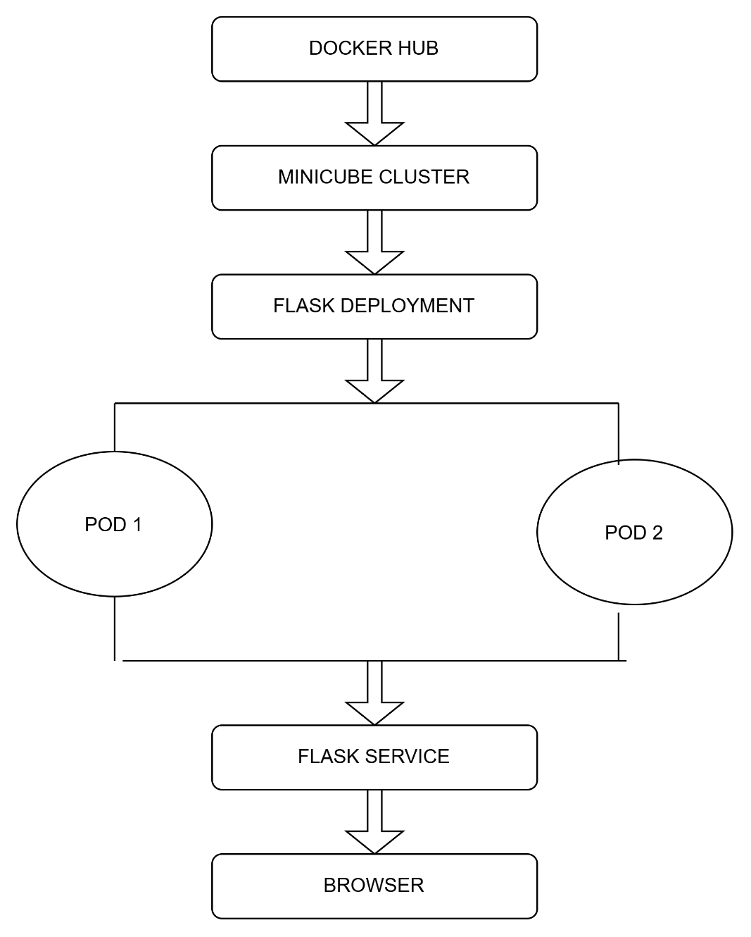
The Flask application was packaged as a Docker image and stored on Docker Hub. The image was deployed to a Minikube Kubernetes cluster using a Deployment manifest. The Deployment initially maintained two replicas of the application. A Kubernetes Service of type NodePort was used to expose the application. The application could then be accessed through the Minikube service URL.
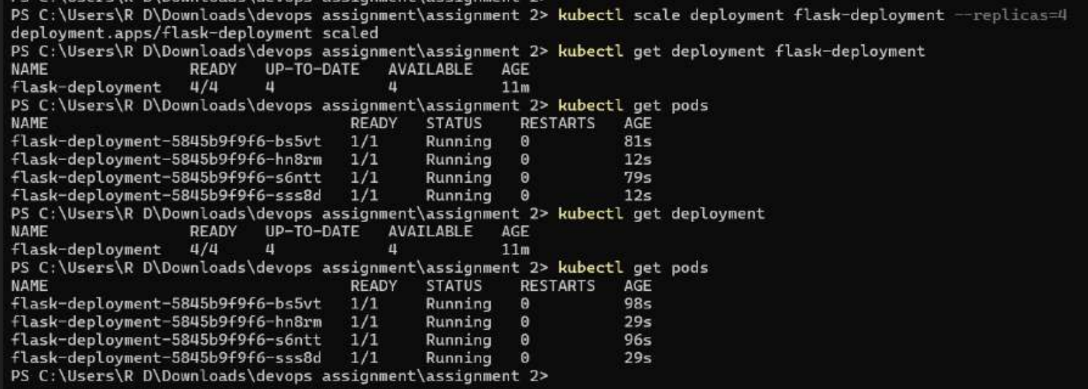
3. Containerization

The Flask application was first containerized using Docker. A Dockerfile was used to define the application environment and dependencies. The resulting Docker image was tagged and pushed to Docker Hub as issnhoiwkfalvaekrema/my-flask-app:v1. Kubernetes used this image to create the application Pods.
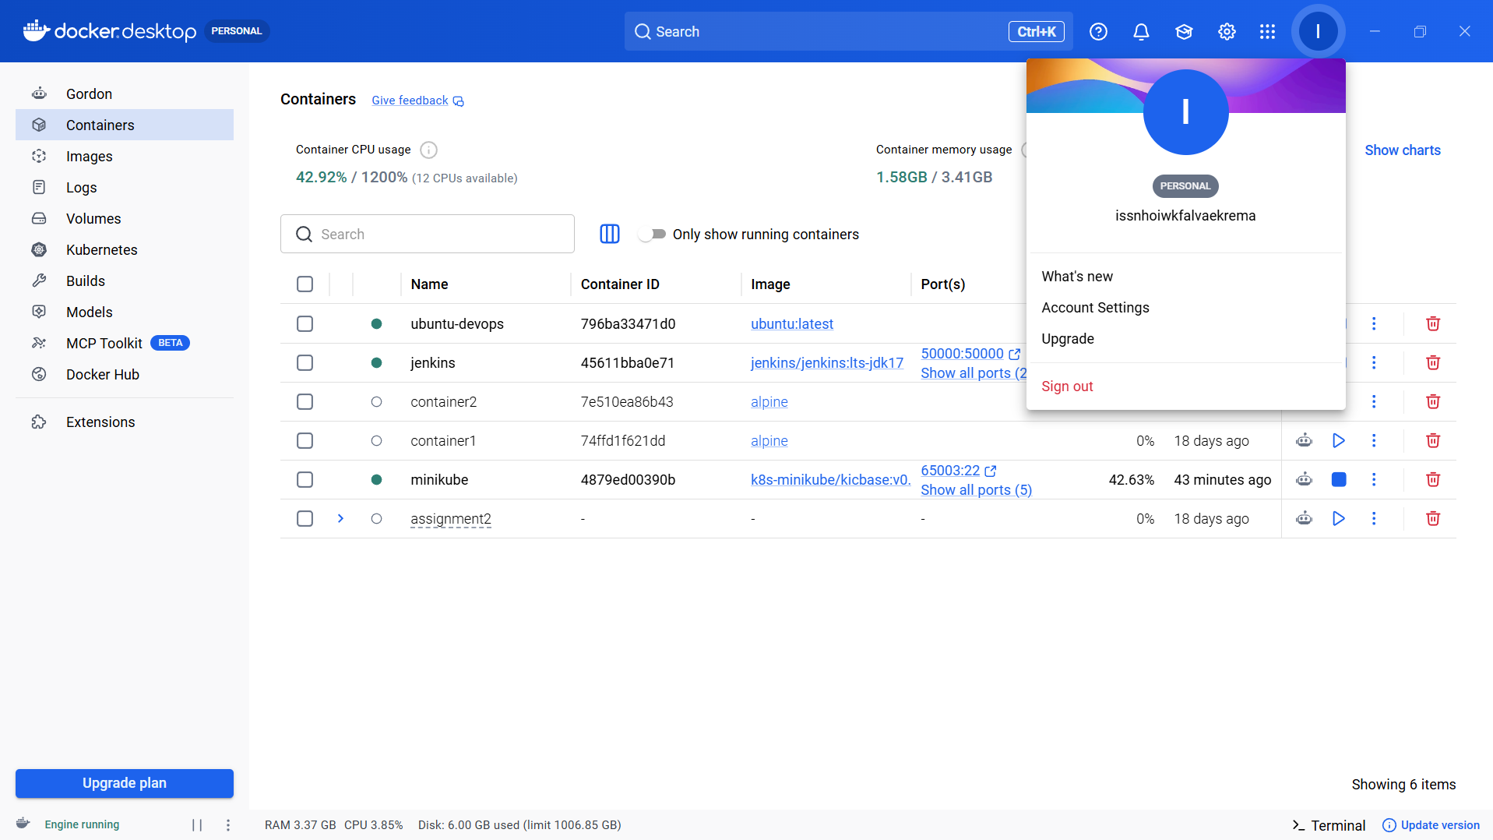4. Kubernetes Deployment
A Kubernetes Deployment manifest was created to manage the Flask application. The Deployment was configured with two replicas. Kubernetes maintained the desired number of Pods and automatically created the required Pods in the Minikube cluster.
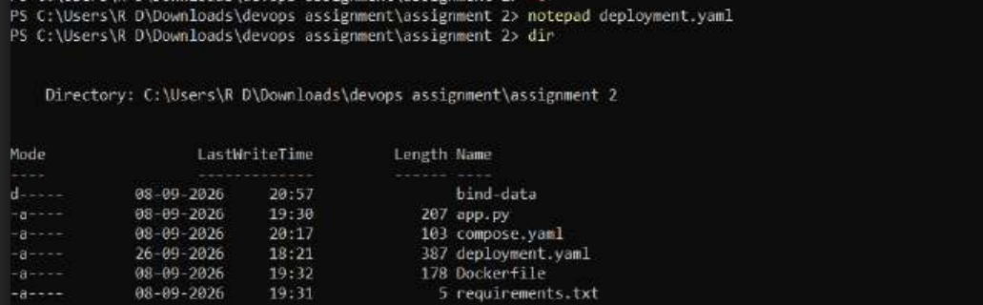
5. Service Configuration
A Kubernetes Service was created to provide network access to the Flask application. The Service used the NodePort type and forwarded traffic from port 5000 to the Flask application's container port 5000.
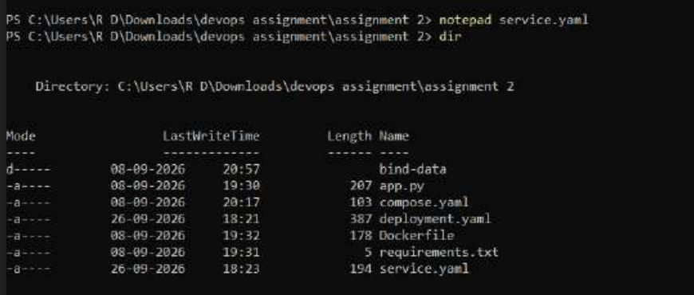
6. Deployment Strategy
A rolling update strategy was demonstrated by updating the Deployment configuration. Kubernetes created a new revision of the Deployment and replaced the existing Pods while maintaining the application availability. The rollout was completed successfully.
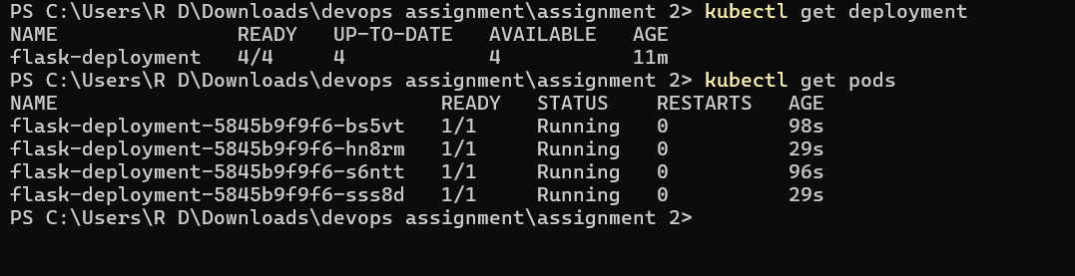
7. Rollback
Kubernetes rollback functionality was demonstrated using the kubectl rollout undo command. The Deployment was successfully rolled back to the previous revision. After the rollback, the application Pods were recreated and returned to the Running state.
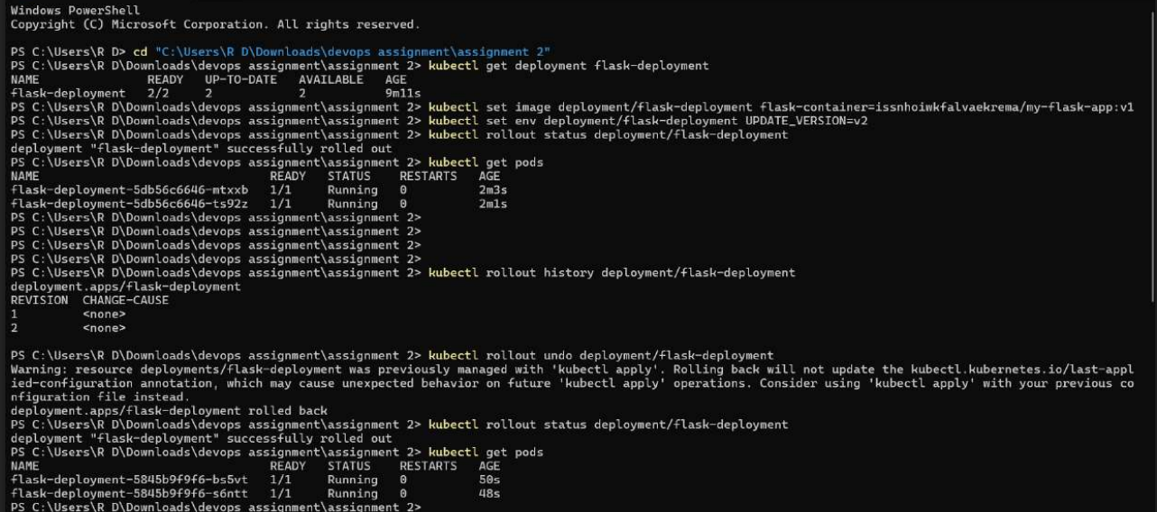

8. Scaling Results
The application was scaled from two replicas to four replicas using the Kubernetes scaling command. After scaling, the Deployment showed 4/4 ready replicas and four application Pods were running successfully.
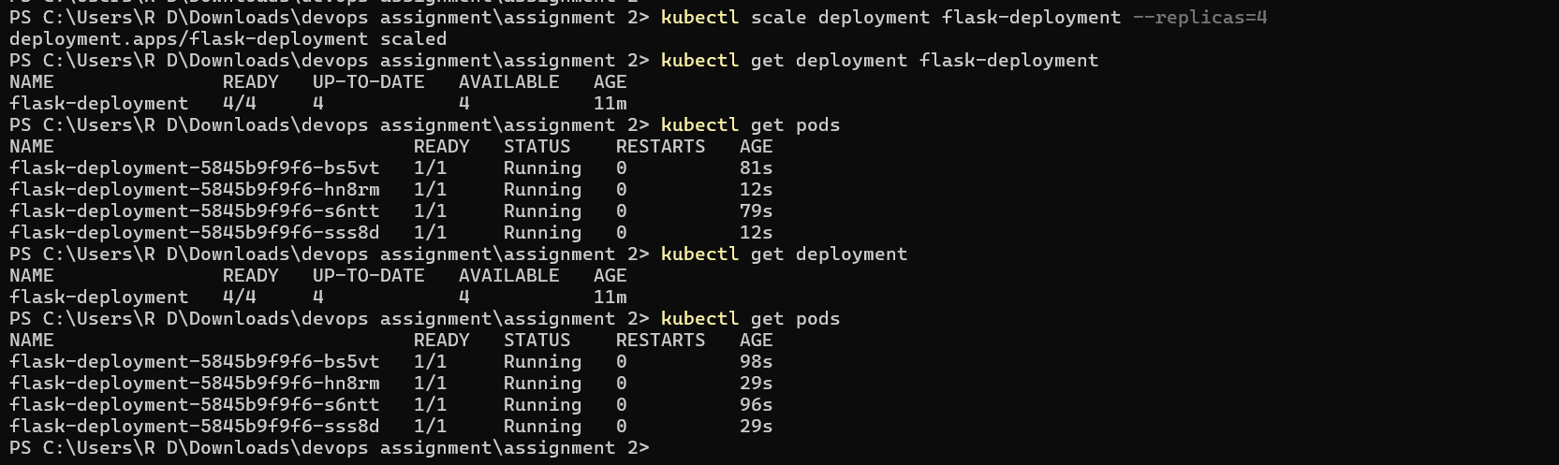

9. Observations
- Docker successfully containerized the Flask application.
- The Docker image was successfully used by Kubernetes.
- Minikube provided a local Kubernetes cluster for deployment.
- The Kubernetes Deployment successfully maintained application replicas.
- The NodePort Service provided access to the Flask application.
- Rolling update created a new Deployment revision successfully.
- Rollback successfully restored the previous Deployment revision.
- Scaling increased the number of application replicas from 2 to 4.
- All four replicas were successfully running after scaling.

10. Conclusion
The containerization and orchestration process was successfully demonstrated using Docker, Docker Hub, Kubernetes, and Minikube. The Flask application was deployed using Kubernetes Deployment and Service manifests. Rolling updates, rollback, and replica scaling were also successfully demonstrated. The final deployment contained four running replicas, showing how Kubernetes can manage and scale a containerized application.

